DEBRIS ASSESSMENT REPORT
FOR THE
IMAGE MISSION

November 1997

SwRI Project 15-8089

Document No. 8089-DAR-01
Revision 1
Contract NAS5-96020

Prepared by



SOUTHWEST RESEARCH INSTITUTE
Instrumentation and Space Research Division
6220 Culebra Road, San Antonio, Texas 78228-0510
(210) 684-5111 • FAX (210) 647-4325
DEBRIS ASSESSMENT REPORT
FOR THE
IMAGE MISSION

SwRI Project 15-8089

Document No. 8089-DAR-01
Revision 1
Contract NAS5-96020

Prepared by: Mark Tapley Date: 6 November 1997
Systems Engineer

Approved by: ______________________________ Date: ____________
W. C. Gibson, Project Manager

Approved by: ______________________________ Date: ____________
J. L. Burch, Principal Investigator

Approved by: ______________________________ Date: ____________
P. Brian Gupta, SwRI Quality Assurance

Approved by: ______________________________ Date: ____________
Frank Volpe, Mission Manager

Instrumentation and Space Research Division
Southwest Research Institute
P. O. Drawer 28510
6220 Culebra Road
San Antonio, Texas 78228-0510
(210) 684-5111
TABLE OF CONTENTS

Page
1. BRIEF BACKGROUND ON PROGRAM AND PROGRAM MANAGEMENT
1.1 Mission Description
1.2 Program/Project Objectives
1.3 Program/Project Schedule
1.4 Responsible program or project manager
2. DESCRIPTION OF DESIGN AND OPERATIONS FACTORS
2.1 Hardware
2.1.1 Physical description of main structure
2.1.2 Description of surfaces/materials exposed to space
2.1.3 Description of spacecraft components most sensitive to debris impact
2.1.4 Description and location of pressurized volumes
2.1.5 Description of on-board propellants
2.1.6 Description and location of fuel storage and transport systems
2.1.7 Description of range safety systems
2.1.8 Description of systems containing stored kinetic energy
2.2 Mission Parameters
2.2.1 Number of Spacecraft
2.2.2 Launch Date and Time
2.2.3 Mission Orbit
2.2.4 Flight Attitude
3. ASSESSMENT OF DEBRIS RELEASED DURING NORMAL OPERATIONS
3.1 Debris Released During Staging, Payload Separation, and Payload Deployment
3.1.1 Description of debris released, size, mass, area, initial orbit, and lifetime
3.1.2 Calculated area-time for debris greater than 1 mm (mm²-year)
3.1.3 Calculated object-time for debris greater than 1 mm (mm²-year)
3.1.4 Calculated time for removal of debris from GEO altitude to at least 300 km below GEO altitude
3.1.5 Source for analysis
3.2 Debris Released During Mission Operations (N/A)
4. ASSESSMENT OF ORBITAL DEBRIS GENERATED BY EXPLOSIONS AND INTENTIONAL BREAKUPS
4.1 Explosions from On-Board Stored Energy
4.1.1 Description of failure modes leading to explosion
4.1.2 Description of systems involved in explosive failure
4.1.3 Estimated probability of explosion
4.1.4 Detailed plan for safing structure after completion of mission
4.2 Intentional Breakups (N/A)
5. ASSESSMENT OF DEBRIS GENERATED BY ON-ORBIT COLLISIONS
5.1 Assessment of Collisions with Large Objects During Mission Operations
5.1.1 Estimated probability of collision with intact space systems or large debris
5.1.2 Plan for limiting probability, if applicable.
5.2 Assessment of Collisions with Small Debris During Mission Operations
5.2.1 Description of primary mission failure modes from meteoroid or orbital debris impact
5.2.2 Description of design measures taken to protect against impacts.
6. DESCRIPTION OF POSTMISSION DISPOSAL PROCEDURES AND SYSTEMS
6.1 Description of Postmission Disposal Option and Disposal System
6.1.1 Statement of disposal option exercised
6.1.2 Disposal plan and description of supporting systems
6.1.3 Source for analysis
6.2 Assessment of Potential Failures that Prevent Successful Postmission Disposal (N/A)
7. ASSESSMENT OF SURVIVAL OF DEBRIS FROM THE POSTMISSION DISPOSAL ATMOSPHERIC REENTRY OPTION
7.1 Verification that Surviving Debris is Within Guidelines
7.2 Source for analysis

REVISION NOTICE

Preliminary Release For Comments: May,1997
Added Delta upper stage analysis and integrated figures from NSS 1740.14
Expanded description of observatory and added illustrations.
Transformed to CDR-45 days report format

Initial Issue: July 2 1997

Revision 1: November 1997
Revised Section 2.2.3. Added results of long-term orbit analysis to Section 6.1.1.

TABLE of TBRÕs
Section 7.1: TBR awaiting analysis of Delta 2 second stage reentry casualty area.

BRIEF BACKGROUND ON PROGRAM AND PROGRAM MANAGEMENT

Mission Description
In-situ measurements made for the past 35 years have yielded a wealth of statistical information about the magnetosphere and its constituent plasma regimes. They have also provided many examples of dynamic changes of magnetospheric plasma parameters at specific times and places in response to changes in the solar-wind input and to internal disturbances related to substorms. However, statistical global averages and individual events are not sufficient to understand the dynamics and interconnections of this highly dynamic system. Fundamental questions concerning plasma entry into the magnetosphere, global plasma circulation and energization, and the global response of the magnetospheric system to internal and external forcing functions remain unanswered. To further our understanding of the physical processes that affect the magnetosphere requires the nearly instantaneous measurement of its topology, that is, magnetospheric imaging.

Program/Project Objectives
To address the basic questions above, IMAGE will provide imaging of three general magnetospheric regions: a) the magnetopause, boundary layer, cusp, and auroral zone; b) the plasmasphere; and c) the inner plasma sheet, ring current, and trapped radiation. IMAGE will also provide images of near-Earth interplanetary space. The data acquired in each of these regions will be used to determine the global structure of the magnetosphere, characterize the connectivity between magnetospheric regions, and place results in a global context with previous in-situ measurements.
The overall objective of IMAGE is to determine the global response of the magnetosphere to changing conditions in the solar wind.

Program/Project Schedule

The IMAGE program carried out a successful Mission Requirements Review in September, 1996. The Confirmation Review allowing the project to proceed to phase C/D was held February 25-27, 1997. The mission CDR was held on August 19-20, 1997. Table 1 is a list of scheduled review dates.
Table 1 - Scheduled Review Dates
Review | Date
MRR | September 10-12, 1996
Confirmation Review  (Mission PDR and NAR) | February 25-27, 1997
CDR | August 19-20, 1997
MOR | June, 1998
PER | August 1999
PSR | October 1999
FRR | December 1999

Instrument delivery to SwRI for integration into a Payload will be in January 1999. Integrated and tested Payload delivery to LMMS for integration into the Spacecraft will be in June 1999. Scheduled launch date is January 1, 2000. The planned mission duration is two years on orbit.

Responsible program or project manager
The Principal Investigator (P. I.), Dr James Burch, is accountable to NASA for the scientific success of the investigation. In accordance with NASA’s transfer of program management responsibility to its Centers, Explorer program management responsibility has been assigned to GSFC. In this role, GSFC is responsible for the exercise of NASA’s fiduciary responsibility to ensure that Explorer missions are achieved in compliance with committed cost, schedule, performance, reliability, and safety requirements. The P. I. and his support team at Southwest Research Institute (SwRI), will be responsible for the overall management of the investigation. With the assistance from the Co-Investigator institutions, SwRI will be responsible for the following elements of the overall program:

- Development of science requirements and the science mission plan;
- Development of the instrumentation and support systems;
- Procurement of the IMAGE spacecraft;
- Integration of the spacecraft and science payload;
- Support for the integration of the spacecraft to the Delta 7326 launch vehicle;
- Initial on-orbit activation of the spacecraft including instruments;
- Training of the GSFC Flight Operations Team;
- Development and operation of the IMAGE science operations functions;
- Acquisition and validation of the data base and implementation of an open data policy for the mission;
- Development and execution of a comprehensive education and public outreach program featuring magnetospheric science;
- Analysis and publication of peer-review science publications;
- Presentation of science results to the scientific community and the public at large; and
- Mission systems engineering and verification.
GSFC will be responsible for the following elements of the IMAGE program:
- Oversight of the MIDEX IMAGE mission on behalf of NASA;
- Procurement of the Delta 7326 launch vehicle; and
- Development and operation of the Science and Mission Operations Center (SMOC).

DESCRIPTION OF DESIGN AND OPERATIONS FACTORS

Hardware

Physical description of main structure
The main body of the IMAGE spacecraft, illustrated in Figure 1 and Figure 2, consists of a honeycomb aluminum octagonal prism 2.2 meters in diameter (across the flats, x and y directions) and 1.362 m tall (z direction). There is an internal octagonal payload deck perpendicular to the z axis and about midway through the prism. The payload deck supports the complement of 6 instruments (counting FUV-WIC, -GEO, and -SI as one, and HENA, MENA, LENA, EUV, and RPI as one each) and the Central Instrument Data Processor (CIDP). The outer panels have face sheets approximately 9 mils thick (both sides). There are interior shear panel structures between the payload deck and the -z panel which support the spacecraft equipment including the Spacecraft Control Unit (SCU), battery, Power Distribution Unit, and other support hardware.
There are two axial antenna booms protruding in the +z and -z directions 10 m each. They are composed of fiberglass lattice structures with a small aluminum end plate, supporting a beryllium copper wire antenna along their entire length. There are 4 radial antennas, composed of beryllium copper with beryllium copper end masses, extending 250m each in the +x, +y, -x, and -y directions.
Cutouts in the side panels permit the imaging instruments to see out in the plane of rotation of the spacecraft. The six imaging instruments require apertures in a variety of sizes and shapes, up to approximately 40 x 54 cm. Several of the instruments have aluminum collimators extending through their cutouts up to a distance of several cm.
The Delta 3rd stage is a STAR 37FM solid rocket motor with nutation damping and a yo-yo despin system. The Delta 2nd stage is a standard Delta launch vehicle second stage with a spin table connecting it to the 3rd stage.
The two yo weights released by the Delta third stage each consist of a flat 978 cm (385) inch by 0.65 cm (0.25 inch) kevlar cable connected to a 5 x 5 x 7.5 cm (2 x 2 x 3 inch) solid metal weight.

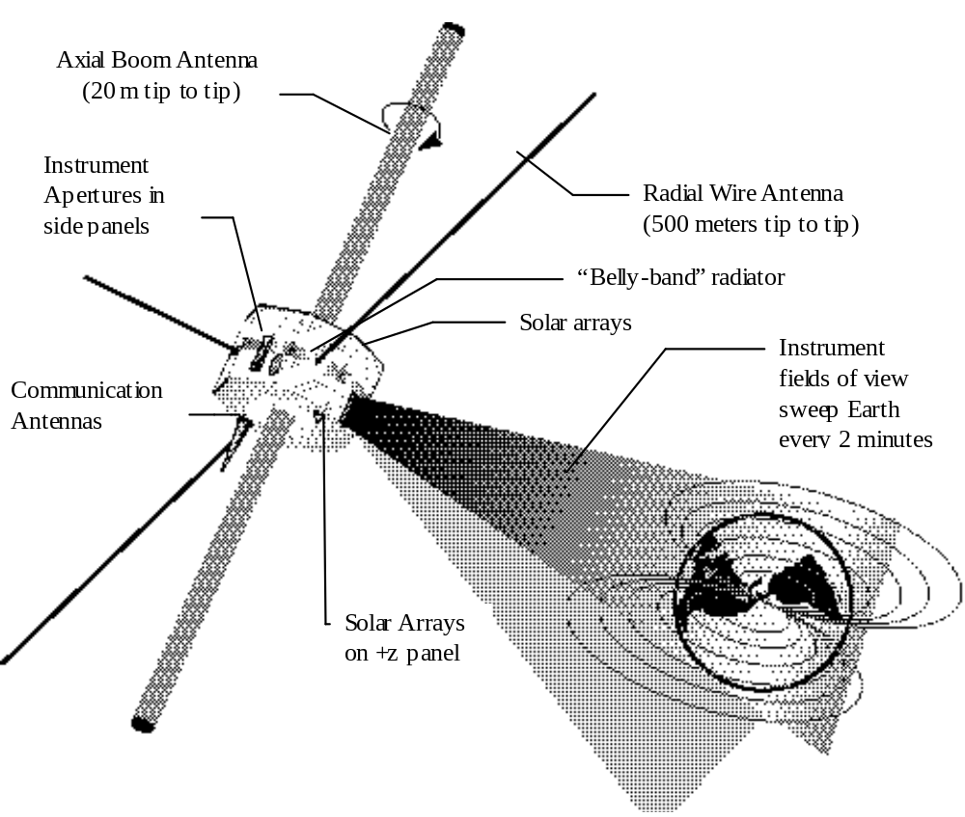
Figure 1: IMAGE orientation in Space (Satellite shown over North Pole)

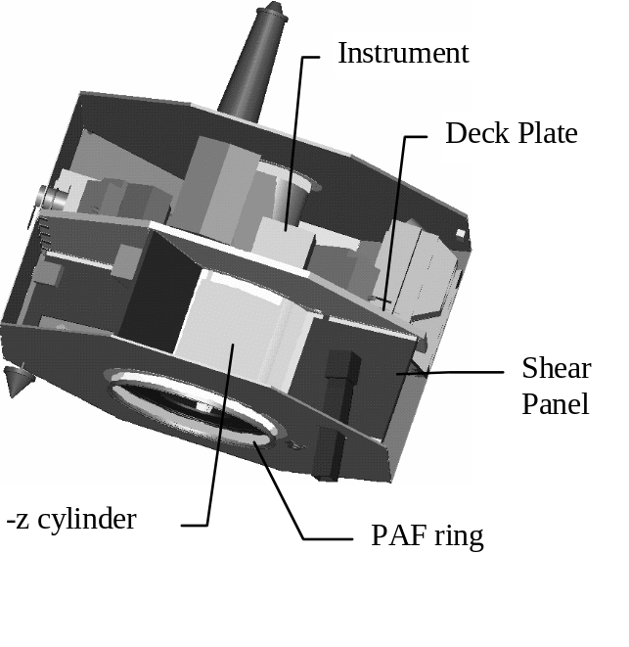
Figure 2: Cutaway illustration of IMAGE internal structure

Description of surfaces/materials exposed to space
The majority of the observatory area exposed to space is composed of solar cells. The remainder of the structure is aluminum, and there is a radiator band about the middle of the spacecraft (at the same level as the payload deck and thermally connected to it) with a Ceramic Optical Surface Reflector (COSR) surface. Instrument collimators have a variety of surfaces including optically black paints or coatings to minimize scattering into their detectors.
The radial stranded Beryllium Copper antennas are not coated and are exposed to space. The axial fiberglass antenna booms and the Beryllium Copper wires they support are not coated and are exposed to space.
Exposed surfaces of the Delta third stage include the aluminum payload support structure, the combustion chamber shell, and the rocket exhaust nozzle. Exposed surfaces for the Delta second stage include the second-stage miniskirt and support truss, the spin table, the pressurized gas spheres (helium and nitrogen), the propellant tanks, and the rocket exhaust nozzle.

Description of spacecraft components most sensitive to debris impact
The critical components of the observatory which maintain orientation include:
- A magnetometer and a star tracker;
- A magnetic torque bar;
- The Spacecraft Control Unit (SCU) for calculation of orientation and commanding the torque bar;
- The Power Distribution Unit (PDU) to supply power to the above;
- A sufficient area of solar panel to activate the above.

There is a battery on the observatory which is used only during eclipse passage. Because of the very high angular momentum of the observatory, complete loss of power during these passages would have little or no adverse effect. The magnetic torquer is not effective except during the low-altitude part of the orbit (< 2 Earth radii).
There are several critical components of the Delta second and third stages which contribute to attitude control and sequencing. These components are situated as on other Delta flights with similar configuration. They are only needed during the first hour of the mission (before spacecraft separation), so their exposure to damage by debris impact is minimal.

Description and location of pressurized volumes
There is a sealed 21-Ah Super Ni-Cad battery to provide electrical power. The FUV GEO sensor contains three 5 ml sealed volumes of Oxygen at a pressure of 205 torr. The Delta second stage contains pressurized volumes of nitrogen and helium.

Description of on-board propellants
There are no propellants on board the observatory. Several of the instruments are considering the use of “dimple motors” to activate their cover releases (The covers remain permanently attached, swinging out of the way on hinges or retracting into cover housings.) Dimple motors are designed to completely contain the gases produced by their activation. All dimple motors will be activated during the on-orbit deployment process.
All of the usable propellant in the Delta third stage is consumed during its burn. The Delta second stage will have some remaining propellant after third stage separation. This propellant will be burned off in a depletion burn after separation from the third stage, which will change only the inclination of the second stageÕs orbit.

Description and location of fuel storage and transport systems
There is no fuel storage or transport system on the observatory.
The Delta third stage STAR 37FM is a solid fuel rocket. Its fuel is stored and used internal to the combustion chamber.
The Delta second stage contains standard facilities for fuel storage and transport. Its fuel is all expended either during the launch or in the depletion burn immediately after third stage separation.

Description of range safety systems
No range safety system is planned for the payload. The Delta third and second stages may contain range safety systems according to standard practice.

Description of systems containing stored kinetic energy
No onboard system contains stored kinetic energy other than the energy associated with the rotation of the entire spacecraft about the z axis.

Mission Parameters

Number of Spacecraft
There is only one spacecraft in the IMAGE mission.

Launch Date and Time
The launch date is nominally January 1, 2000 and no later than March 2000. The time of day is chosen to satisfy a right ascension of the ascending node of 0 or 180 degrees from the vernal equinox.

Mission Orbit
The mission orbit, Figure 1, is an elliptical polar orbit (90.0 degrees inclination) with a perigee altitude of 1000 km and an apogee altitude of seven (7) Earth radii. The argument of perigee at launch is 320 degrees, and during the mission it progresses to 220 degrees. During the mission, apogee is always in the northern hemisphere and is over the north pole at the mission half way point. The ascending node is chosen to be either 0 or 180 degrees. Thermal and power considerations constrain the orbit to be within 15 degrees of one of these target ascending node locations.
The Delta third stage will occupy the same orbit after separation.
After separation, the Delta second stage will occupy an orbit with a perigee altitude of 185 km, an apogee altitude of 1073 km, and an inclination of 89.79 degrees (the inclination may be affected by the depletion burn).

Flight Attitude
The spacecraft is spin stabilized with its axis of spin perpendicular to the orbit plane. The sense of spin is retrograde to the orbit circulation (i.e. the spin vector is opposite to the orbit angular momentum vector).
The Delta third stage is not stabilized after de-spin, but its residual spin and nutation damper will tend to keep its axis aligned in the plane of the orbit.
The Delta second stage will be stabilized by its on-board control system until its batteries are discharged, after which it is not stabilized.

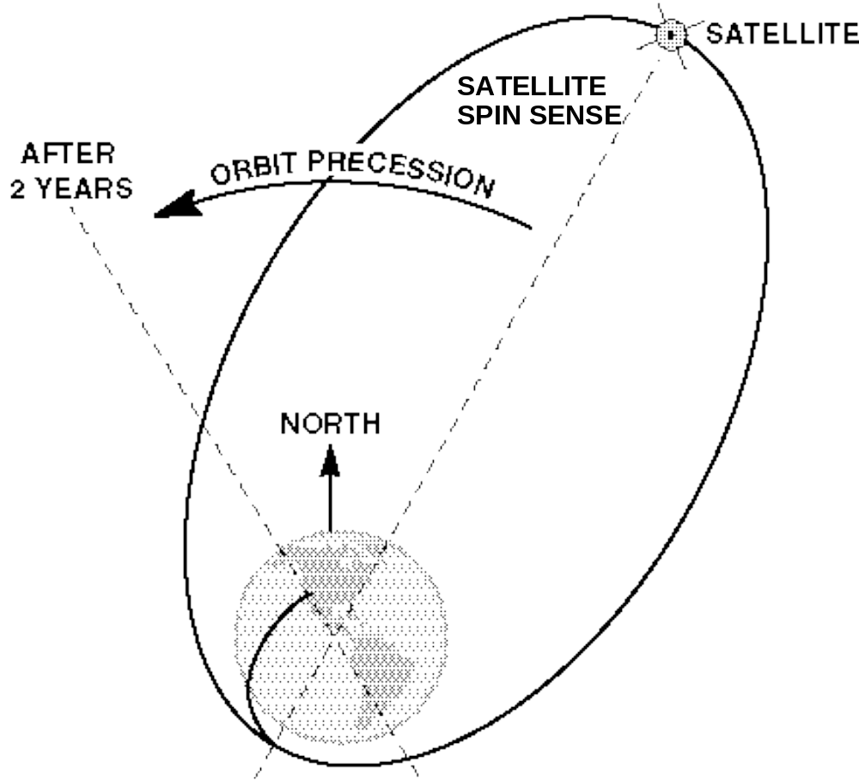
Figure 3: IMAGE Mission Orbit

Assessment of Debris Released During Normal Operations

Debris Released During Staging, Payload Separation, and Payload Deployment

Description of debris released, size, mass, area, initial orbit, and lifetime
The Delta second stage is released at separation. The separated second stage has an overall area of approximately 9.8 m² (105 square feet) and a Ballistic Coefficient (W/CdA) of 8.4 lb/ft², which gives an area mass density of approximately 0.024 m²/kg. As described above, after separation, the Delta second stage will occupy an orbit with a perigee altitude of 185 km, an apogee altitude of 1073 km, and an inclination of 89.79 degrees (the inclination may be affected by the depletion burn). Orbit lifetime for the 1073x185 km orbit is predicted by the Debris Assessment Software (Version X.09) to be 0.0638 years.
A system of yo weights with kevlar cables is used to de-spin the Delta third stage. The yo weights are released to carry away the excess angular momentum associated with the spin of the stage and observatory. The yo weights are compact metal masses, with attached flat ribbon kevlar cables 9.77 meters (385 inches) long. Projected area of the released yos is approximately 0.0362 m².(56 square inches). Mass of the yo weight plus the kevlar cable is approximately 0.78 kg (1.72 lbs). Area-to-mass ratio is approximately 0.046 m²/kg. The yo weights and cables occupy the mission orbit. As described above, the mission orbit is an elliptical polar orbit (90.0 degrees inclination) with a perigee altitude of 1000 km and an apogee altitude of seven (7) Earth radii. The argument of perigee at launch is 320 degrees. Orbit lifetime is not predicted accurately by either Figure 3-2 of the NASA Safety Standard Guidelines and Assessment Procedures for Limiting Orbital Debris (NSS 1740.17) or by the Debris Assessment Software (Version X.09). Extrapolating on Figure 3-2 (reproduced below as Figure 4 for convenience) indicates that the orbit lifetime may be on the order of 3,000,000 years.
The Delta third stage is the last piece of debris released during launch operations. The separated third stage has an area of approximately 3.05 m² (32.8 square feet) and a Ballistic Coefficient (W/CdA) of 11.2 lb/ft², which gives an area mass density of approximately 0.02 m²/kg. The third stage occupies the same mission orbit as the yo weights. As with the yo weights, orbit lifetime is not accurately predicted by either Figure 3-2 of the NASA Safety Standard Guidelines and Assessment Procedures for Limiting Orbital Debris (NSS 1740.17) or by the Debris Assessment Software (Version X.09) and may be on the order of 3,000,000 years.

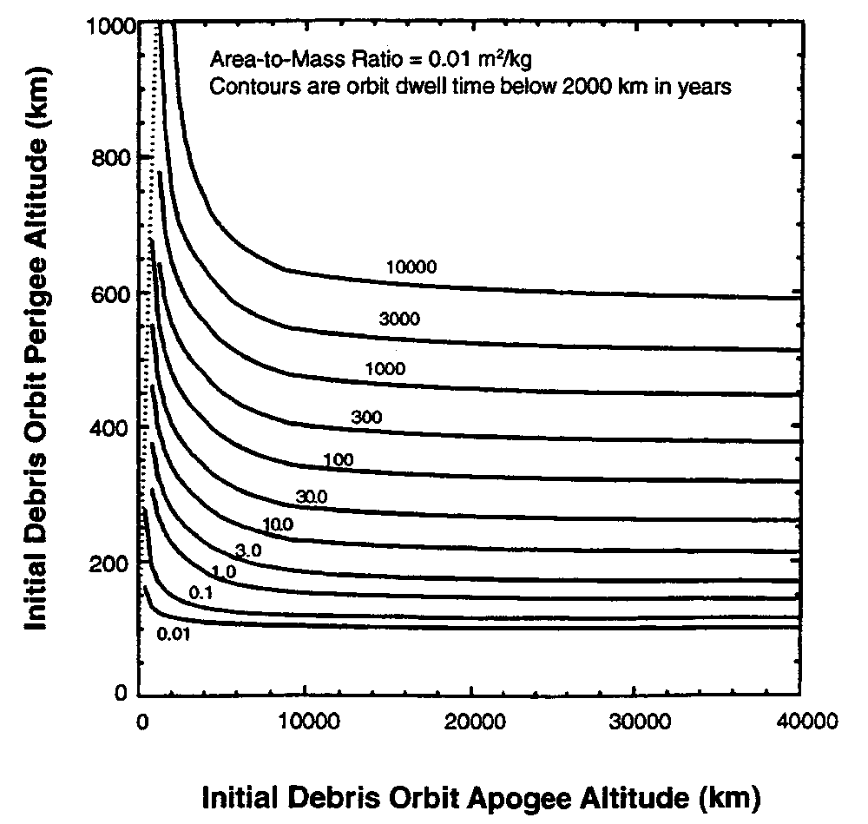
Figure 4: (NASA NSS 1740.14 Figure 3-2) Orbit dwell times below 2000km for debris released in high eccentricity orbit. Radiation pressure effects and lunar and solar gravity perturbations neglected in the calculation or orbit lifetime.

Calculated area-time for debris greater than 1 mm (mm²-year)
The area of the second stage given above is 9.8 m². The predicted orbital lifetime given above is 0.0638 years. The area-time product of the second stage is therefore 0.625 m²-years.
The area of the yos is given above as 0.036 m². The orbital lifetime is taken to be 3,000,000 years in accordance with the fairly uncertain estimate given above. During each orbit, approximately 2.55% of the orbit period is spent below 2000 km altitude. Taking this factor times the estimated orbit lifetime times the area gives an area-mass product for each yo of 2754 m²-years. There are two yos. Using the above approximations indicates that the total area-time product for the despin system will be approximately 5508 m²-years.
The area of the Delta third stage is given above as 3.05 m². The orbital lifetime is taken to be 3,000,000 years in accordance with the estimate above. During each orbit, approximately 2.55% of the orbit period is spent below 2000 km altitude. Taking this factor times the estimated orbit lifetime times the area of the third stage gives an area-mass product of 233,000 m²-years. The total object-year product for the Delta third stage will be approximately 75,000 object-years.

Calculated object-time for debris greater than 1 mm (mm²-year)
The Delta second stage is a single body for which the orbital lifetime has been calculated to be 0.0638 years. The total object-time product for the Delta second stage will be approximately 0.0638 object-years.
There are two yo weights in the despin system. The approximations above indicate that the lifetime of both objects may be approximately 3,000,000 years, of which 2.55% ( 76,500 years) will be spent below an altitude of 2,000 km. The total object-time product for the despin system will be approximately 153,000 object-years.
The Delta third stage is a single body. The approximations above indicate that its lifetime may be approximately 3,000,000 years, of which 2.55% ( 76,500 years) will be spent below an altitude of 2,000 km. The total object-time product for the Delta third stage will be approximately 76,500 object-years.

Calculated time for removal of debris from GEO altitude to at least 300 km below GEO altitude
The Delta second stage will never attain geosynchronous altitude and will soon reenter.
The yo weights of the despin system and the third stage will all be in a highly elliptical orbit whose apogee is above geosynchronous altitude. Their long-term disposal will be the same as for the Observatory. See Section 6 for details.

Source for analysis
All orbital lifetime calculations presented in this section were made by or interpolated from charts preseted in the NASA Safety Standard Guidelines and Assessment Procedures for Limiting Orbital Debris (NSS 1740.17) or by the Debris Assessment Software (Version X.09).

Debris Released During Mission Operations (N/A)
No debris is released during normal or contingency mission operations.

Assessment of orbital debris generated by explosions and intentional breakups

Explosions from On-Board Stored Energy

Description of failure modes leading to explosion
The only credible scenario leading to explosion aboard the Observatory is mismanagement of battery charging leading to battery explosion. No other sources of energy capable of causing explosion are available on the Observatory.
The second stage will contain an undetermined amount of unburned propellant following its last cutoff during ascent. This propellant could cause an explosion if allowed to burn in an uncontrolled manner.

Description of systems involved in explosive failure
The complete battery including pressure vessel and electrolyte has a mass of 22.5 kg. Its active chemical composition is a Nickel-Cadmium system. The energy storage capability of the battery is 21 Amp hours at 28 Volts. The overall battery energy density is no more than 21*3600*28 Joules/ 22.5 kg = 94,080 J/kg at full charge. Later in the mission, as the maximum solar array output voltage decreases due to radiation exposure, the maximum energy density will decrease.
The second stage will contain A-50 propellant and N₂O₄ oxidizer. The effective energy density of the propellant can be estimated from its specific impulse to be approximately 4.9*10⁶ Joules/kg. The total mass of unburned propellant cannot be accurately estimated, but will be a small fraction of the total available propellant.

Estimated probability of explosion
Pre-launch testing will mitigate the chance of an error in the design of the battery or charge control circuitry which could lead to dangerous conditions. The charge control circuitry is composed of rad-hard components with sufficient redundancy to render the chance of a latchup or other radiation-caused event negligible. Neither of these causes is seen as a credible scenario leading to battery failure. The design of the spacecraft is such as to protect the battery from debris or meteor impact by enclosing it within honeycomb of at least 0.020 inches total thickness. This protection is adequate to make the probability of impact-caused explosion also negligible. The probability of a battery explosion is very small and is not quantified in this assessment.
The probability of an explosion in the second stage before its depletion burn uses up all of its remaining propellant is also very small due to the short elapsed time before the depletion burn. This probability is not quantified in this assessment.

Detailed plan for safing structure after completion of mission
The Delta Second Stage will burn off its remaining propellant in a depletion burn (directed so as to change only the inclination of its orbit) after separation from the third stage. The probability of explosion will drop to zero after completion of this burn.
The battery is charged by solar arrays on the exterior of the spacecraft. The orbit passes through radiation belts which will be detrimental to the performance of the solar cells, both in charging current and in open-circuit voltage produced. Analysis indicates that within approximately 5 years, the open-circuit voltage produced by the solar cells will be less than the minimum charging voltage of the battery. After this happens, the battery will discharge within two eclipse-season orbits to a zero charge state and will never recover its charge. The stored charge in the battery is therefore not a credible source of explosions after the five-year point.

Intentional Breakups (N/A)
The IMAGE program will not involve any intentional breakup of on-orbit hardware.

ASSESSMENT of Debris Generated by On-Orbit Collisions

Assessment of Collisions with Large Objects During Mission Operations

Estimated probability of collision with intact space systems or large debris
We compute the estimated probability of the Observatory undergoing collision in the Table below. The altitude bands are chosen to accommodate Figure 5-1 of the NASA Safety Standard Guidelines and Assessment Procedures for Limiting Orbital Debris (NSS 1740.17), which provides the area flux values. That figure is reproduced below (Figure 5) for convenience.

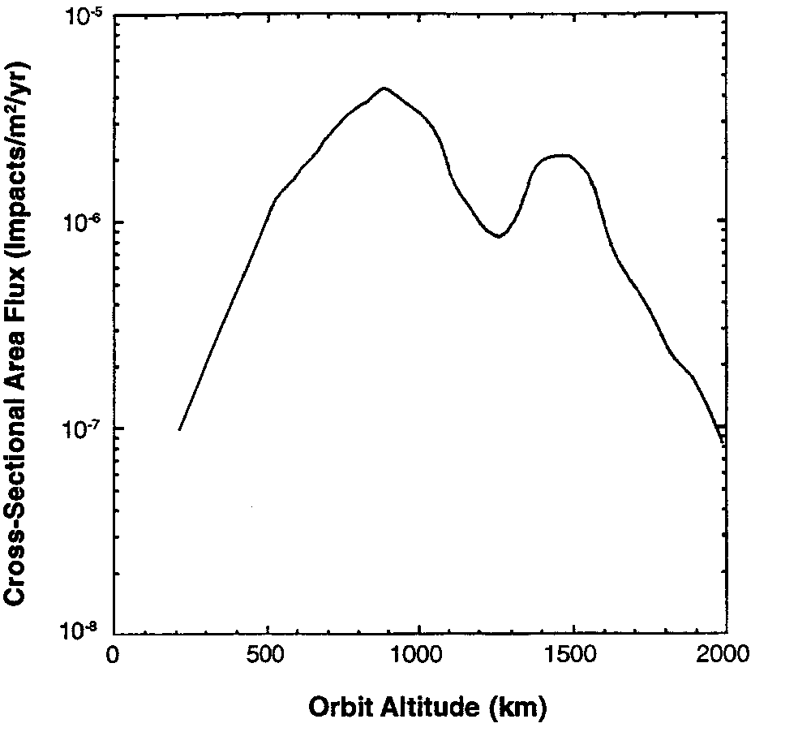
Figure 5: (NASA NSS 1740.14 Figure 5-1) Cross-sectional area flux of intact space systems and large orbital debris.

The Total Time in each altitude band is calculated based on the mission orbit described in paragraph 2.2. Table 2 shows cumulative time spent in each band during the mission.
Table 2 - Cumulative Time In Each Altitude Band
Altitude Band | Total Time in Band | Area Flux | Time-Flux Product
(km) | (years) | (Impacts/m²/year) | (Impacts/m²)
1000-1100 | 0.007737 | 2.50E-06 | 1.93E-08
1100-1370 | 0.007342 | 1.30E-06 | 9.54E-09
1370-1600 | 0.004337 | 1.70E-06 | 7.37E-09
1600-1690 | 0.001495 | 8.00E-07 | 1.2E-09
1690-1790 | 0.001571 | 4.00E-07 | 6.28E-10
1790-1920 | 0.00193 | 2.00E-07 | 3.86E-10
1920-2000 | 0.001136 | 1.20E-07 | 1.36E-10
 |  | Sum (impacts/m²) | 3.9E-8

Taking the Sum of the Time times Flux products and multiplying by the projected area of the spacecraft, approximately 6 m², gives the total probability of collision of 2.3e-7. This is well below the guideline of 0.001.

Plan for limiting probability, if applicable.
Since the probability of collision is lower than the guideline by a factor of approximately 4000, no action is contemplated to reduce that probability.

Assessment of Collisions with Small Debris During Mission Operations

Description of primary mission failure modes from meteoroid or orbital debris impact
There are several components critical to Observatory operation which are susceptible to debris impact. They have been divided into two lists in Table 3. The first list contains components which are exposed to direct debris impacts. The second list contains components which are protected inside the aluminum honeycomb body of the Spacecraft. The systems identified as critical to operation of the science instruments but not critical to Observatory survival, attitude maintenance, and communication are marked with an asterisk (*).

Table 3 - Critical Components Susceptible to Debris Impact
Exterior Critical Items
Sun Sensor, Star Tracker (One or the other must be operational)
Solar Panels
Instrument Collimators/Filters*
Interior Critical Items
Power Distribution Unit
Battery
Spacecraft Control Unit
Spacecraft Cable Harnesses
Solid State Memory*
Central Instrument Data Processor*
Payload and S/C to P/L Cable Harnesses*

Destruction of or damage to any of the instrument exterior components would adversely affect operation of that instrument without affecting the remainder of the payload. Damage to the solar panels may adversely affect the power cycle of the observatory during eclipse season or, if severe enough, during all operations. Damage to both the sun sensor and the star tracker would disable all baseline methods of attitude determination. It is possible that one or more instruments could be used as an attitude reference, but this possibility has not been studied in depth.
Damage to any of the components on the interior critical items list would effectively terminate science operations.
Postmission disposal plans would not be affected by damage to any component of the observatory.

Description of design measures taken to protect against impacts.
The design of the Observatory, with exterior structural panels protecting most of the components, minimizes the probability of destructive collision with debris. All sensitive exterior components are required to be exterior components to fulfill their design function; shielding of these components is not practical. All interior components are protected from impacts with objects up to at least 0.020 inches in diameter by the exterior panels. The costs of adding additional shielding (in terms of mass and budget) are evaluated to be higher than the benefits associated with the reduced probability of damage.
The post-mission disposal plans do not require functionality of any components of the IMAGE Observatory. Therefore, the probability of collision with small debris preventing postmission disposal according to plan is zero.

Description of Postmission Disposal Procedures and Systems

Description of Postmission Disposal Option and Disposal System

Statement of disposal option exercised
The planned disposal procedure for the IMAGE observatory is deactivation in mission orbit. The yo weights and Delta third stage will also remain in this orbit. No engines or other devices are used to alter the orbit. The science orbit for this mission is used very little by other spacecraft. Table 4 shows the time fraction of an orbit which is spent in any of the sensitive regions as defined in Figure 6-1 of the NASA Safety Standard Guidelines and Assessment Procedures for Limiting Orbital Debris (NSS 1740.17).

Table 4- Fraction of Time Spent in Sensitive Regions
Sensitive Orbit Regions | Fraction of time
Low Earth Orbit (<2,500 km altitude) | 3.2%
Semi-Synchronous orbit (19,900 km < altitude < 20,500 km) | 0.8%
Geo-Synchronous orbit (35,288 km < altitude < 36,088 km) | 2.1% **

**The polar inclination of the orbit combined with the precession of perigee at a rate of approximately 50 degrees per year means that the orbit will pass through the sensitive equatorial geo-synchronous region only 4 times every 7 years. The 2.1% figure is thus an extremely pessimistic upper limit on the time spent in the geosynchronous equatorial region.
The long-term effect of luni-solar perturbations to the orbit has been analyzed by Nicholas L. Johnson of Johnson Space Flight Center, SN3. The primary effect predicted is an oscillation in the perigee altitude of objects in the mission orbit. The perigee will oscillate between values of approximately 500 km and approximately 1600 km, with a period of oscillation of approximately 1400 days. (The initial direction of change will be toward a high-altitude perigee, so there are no adverse effects on the science mission.) No other significant effects on the orbit were reported. Because of their cyclical nature and small amplitude, these perturbations do not substantially affect any of the calculations presented in this document.

Disposal plan and description of supporting systems
After separation, the inert (spent) Delta third stage and yo masses will serve no further mission functions. No further operations involving them are planned.
At termination of operations for the Observatory, the instruments will be commanded to a safe condition to prevent sun damage to the sensors. The attitude control system will be commanded to maintain the Observatory in the science mission attitude. The system will be placed in a state where removal and re-application of battery power will cause it to come up in a stable condition, if that is not the normal flight mode. The solid state recorder will continue to operate but will over-write data older than approximately 21 hours (and no science data will be available except from instruments which are always sun-safe, such as RPI). Broadcast transmission of real-time data for NOAA or other users will continue unless commanded off to clear radio bandwidth. The Observatory can be reactivated from this state by uploading appropriate ephemeris data, checking operation of the attitude control system, and reactivating the instrument. Operations aboard the Observatory will continue, cycling the battery during eclipse season.
As solar panel output deteriorates, the Spacecraft computer will gracefully load-shed by powering off instruments and nonessential systems. Within about five years, radiation damage to the solar panels will cause their open-circuit voltage output to drop below the charging voltage for the battery. The next one or two eclipses will discharge the battery to its full-discharge state and it will not recover. The Observatory will power down during and recover after each succeeding eclipse. At some later time the panel output will drop to a voltage too low to power up the Spacecraft Control Unit. At this point the Observatory will no longer be operable.

Source for analysis
All analysis used in this section was taken from the NASA Safety Standard Guidelines and Assessment Procedures for Limiting Orbital Debris (NSS 1740.17) or done by the Debris Assessment Software (Version X.09).

Assessment of Potential Failures that Prevent Successful Postmission Disposal (N/A)
No obstacles to the postmission disposal plans described above have been identified.

Assessment of Survival of Debris from the Postmission Disposal Atmospheric Reentry Option

Verification that Surviving Debris is Within Guidelines
Atmospheric re-entry is not contemplated as a disposal option for the IMAGE observatory, Delta third stage, or de-spin yo masses.
The Delta second stage will reenter less than one month after separation. Analysis of debris survival of reentry is not complete at this point, but should not differ substantially from normal Delta second stage reentry (TBR). A complete analysis or reference to a previously completed analysis will be appended to this Debris Assessment Report as soon as possible.

Source for analysis
All analysis used in this section will be taken from the NASA Safety Standard Guidelines and Assessment Procedures for Limiting Orbital Debris (NSS 1740.17) or done by the Debris Assessment Software (Version X.09).

