POLARIZATION OF FIELD ALIGNED PROPAGATING ECHOES IN THE PLASPMASPHERE USING THE RADIO PLASMA IMAGER

G. S. Sales⁽¹⁾, B. W. Reinisch⁽²⁾, X. Huang⁽³⁾ I. A. Galkin⁽⁴⁾, and J.L. Green⁽⁵⁾

⁽¹⁾Center for Atmospheric Research, University of Massachusetts Lowell, 600 Suffolk Street,

Lowell, MA 01854, USA, Gary_Sales@uml.edu
⁽²⁾As above, but E-mail: Bodo_Reinisch@uml.edu
⁽³⁾As above, but E-mail: Xueqin_Huang@uml.edu
⁽⁴⁾As above, but E-mail: Ivan_Galkin@uml.edu
⁽⁵⁾NASA Goddard Space Flight Center, Greenbelt, MD, USA, green@mail630.gsfc.nasa.gov

ABSTRACT

Analysis of radio plasma imager (RP plasmagrams show that echo signals often propagate along the earth’s magnetic field to both hemispheres. Using measured signals on RPI’s orthogonal antenna system makes it possible to determine not only the arrival direction but also the polarization characteristics of the arriving wave. The measured arrival-angles are nearly parallel or anti-parallel to the local magnetic field. Based on plasmagram trace inversions, it has been concluded that these echoes are X mode waves. This result is confirmed here; all analyzed traces were X-mode, though the observed polarization ellipses were often not circular.

INTRODUCTION

Magnetically field-aligned propagation dominates the radio signals from RPI/IMAGE whenever the satellite enters or leaves the plasmasphere. Analysis of 352 orbits of RPI over a nine month period has shown that field aligned propagation (FAP) modes were present on approximately 1/3 of the passes through the plasmasphere. These signals appear to propagate along the magnetic field passing through the satellite position, often to both the northern and southern hemispheres. Depending on the satellite location relative to the magnetic equator, the length of these two paths differs. After reflection, the radio waves return to the satellite along the same path. Fig. 1 is an example of a plasmagram when the IMAGE is at L ≈ 3.

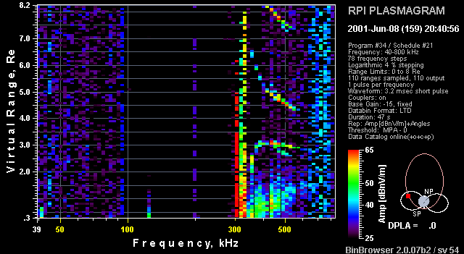
Short path trace
Northern hemisphere
Long path trace
Southern hemisphere

Fig. 1. Typical RPI plasmagram (June 8, 2001; 2040:56 UT) as IMAGE enters the plasmasphere. Indicated are the short path from the northern hemisphere and the long path from the southern hemisphere.

The two traces, labeled short and long path, are from the northern hemisphere and the southern hemisphere, respectively. The strong resonance line, just above 300 kHz, corresponds to the local plasma frequency.

Over the analysis period, these FAP modes were observed on L-shells from L = 2 to L = 4. An important consideration in understanding the structure of these propagation modes is that these traces appeared on sequential plasmagrams, typically separated by four minutes, about 41 % of the time. These FAP traces are, in general, not isolated events, but are often strung together on two, three or more sequential plasmagrams.

Using the measured voltages received on the three orthogonal antennas on board the RPI/IMAGE satellite, a technique was developed to uniquely determine the arrival-angle (with a 180° ambiguity) and the polarization of all echoes from both the northern and southern hemispheres. Fig. 2 illustrates the signal flow from transmission to reception and the processing done to determine the echoes’ arriving direction and polarization.

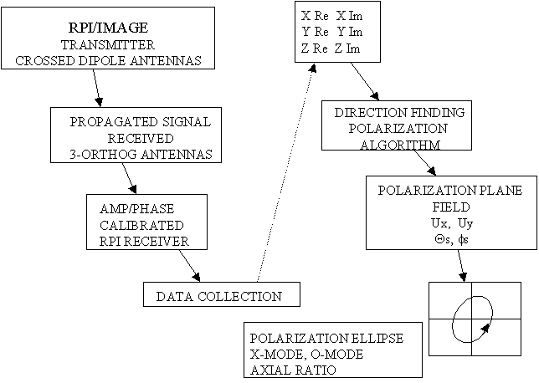

Fig. 2. Flow chart for RPI signal acquisition and processing including the determination of the polarization of the received echo.

The arriving wave is illustrated in Fig. 3 at an angle with respect to the local magnetic field vector B. The technique developed here begins with the received signals on the three orthogonal antennas (X,Y,Z) and works back towards the electric field intensity vector of the arriving wave in the polarization plane.

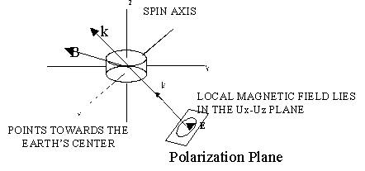

Fig. 3. Relationship between the arriving wave in the polarization plane and the local magnetic field at the satellite.
k
B
The results of the analysis of a small test data sample showed that the received signals arrived from directions clustered near the local magnetic field direction. Fig. 4 compares the azimuth and zenith angles of the arriving waves with the local magnetic field directions.

E

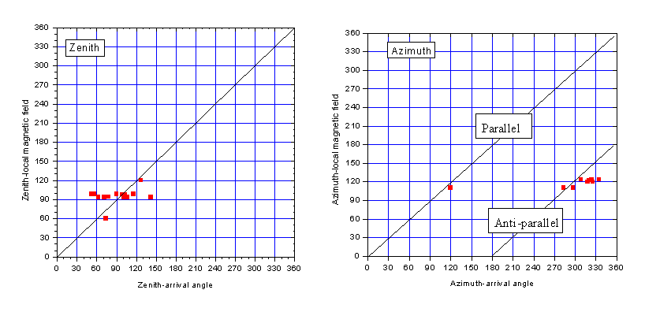
Fig. 4. Comparison of the arrival angles (azimuth and zenith) of the field-aligned reflected waves and the local magnetic field direction.

Here parallel and anti-parallel refer to signals reflected from the southern hemisphere and the northern hemisphere, respectively. The spread in the measured arrival angles (Fig. 5) is likely caused by uncertainties in the pre-launch calibration. This issue is being addressed at this time.

Field aligned propagated (FAP) signals observed from both hemispheres where exclusively X-mode polarized. This supports the observations by Reinisch et al. [1] based on their electron density profile inversion procedure.

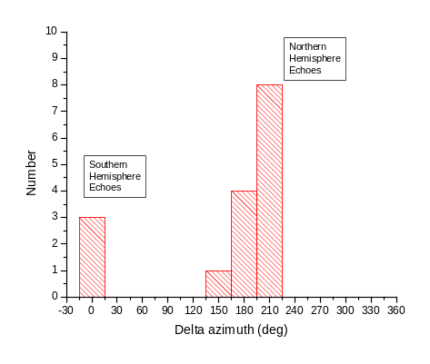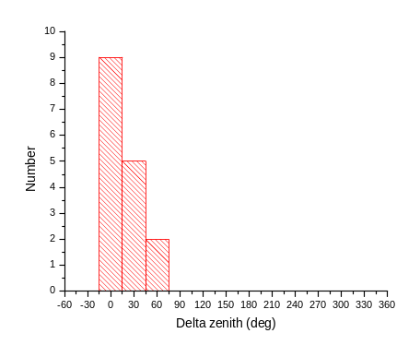
Fig. 5. Distribution of the arrival angles for both northern and southern hemisphere reflections.

The amplitude of FAP modes appear to decrease with a rate less than 1/r; the RPI system often records multiple hemisphere-to-hemisphere echoes indicating low spreading losses. Ray tracing simulations at small angles to the magnetic field direction were conducted to determine the expected spreading losses. Using the 3-dimensional HASEL ray tracing code a comparison is made between O-mode and X-mode propagation losses as a function of the angle the rays make with the earth’s magnetic field. A systematic analysis of the amplitude of these FAP modes has been carried out and compared to the propagation models proposed here.

SUMMARY

In the plasmasphere/plasmapause region RPI field-aligned propagating signals are observed on more than 30% of the orbits. These FAP modes are often observed in a sequence of plasmagrams over a range of L-shells that is indicative of the complex nature of the plasmasphere at certain times.

All the processed traces analyzed to date have been identified as X-mode polarization supporting the results of the Huang and Reinisch electron density inversion analysis reported in [1]. These signals are sometimes near-circularly polarized, though more near-linearly polarized signals often appear at the higher frequencies along the traces.
These near-linearly polarized signals occur at a significant fraction of time. We suspect that the observed axial ratio deviation from circular and the sometimes-significant deviations of the arriving signal angles with respect to the local magnetic field direction result from a combination of weak signal-to-noise ratios and improper receiver calibrations.

REFERENCE

[1] Reinisch, B.W., X. Huang, P. Song, G.S. Sales, S.F. Fung, J.L. Green, D.L. Gallagher and V.M. Vasyliunas, Plasma Density Distribution Along the Magnetospheric Field: RPI Observations From IMAGE, Geophys. Res. Lttrs, 28, 24, 4521-4524, 2001.

UML was supported by NASA under subcontracts from Southwest Research Institute.

